**Report1.**

CREATE VIEW V_REPORT1

AS

SELECT U.FIRSTNAME,U.LASTNAME,U.EMAIL,VT.VERSION_DESC,VT.VERSION_START_DATE,VT.VERSION_END_DATE

,P.PLAN_TYPE,PCODE.PROMOCODEID_PK AS PROMOCODE ,PC.CARD_NUMBER,UP.TOTAL_PAYMENT

FROM T_USER U

INNER JOIN T_BRIDGE B ON U.USERID_PK = B.USERID_FK

INNER JOIN T_PLAN P ON B.PLANID_FK = P.PLANID_PK

LEFT JOIN T_USER_PAYMENT UP ON U.USERID_PK = UP.USERID_FK AND P.PLANID_PK = UP.PLANID_FK

LEFT JOIN T_VERSION_TYPE VT ON UP.VERSION_TYPE_ID_FK = VT.VERSION_TYPE_ID_PK

LEFT JOIN T_PAYMENTCARD PC ON UP.PAYMENTID_PK = PC.PAYMENTID_PK

LEFT JOIN T_PROMOCODE PCODE ON UP.PROMOCODEID_FK = PCODE.PROMOCODEID_PK

**Note:**

The View would be generated and the user should be able to run the select SQL with multiple where condition (filters).

Total_PAYMENT is added from the previous assignment. There was a referential integrity issue between PlanID & UserID combination in T_PLAN table and T_USER_PAYMNET table and the record was corrected in one of the T_USER_PAYMNET table to make it aligned. There are few null records in Version_Desc and Version_Start_Date due to user not having any payment transaction which is expected.

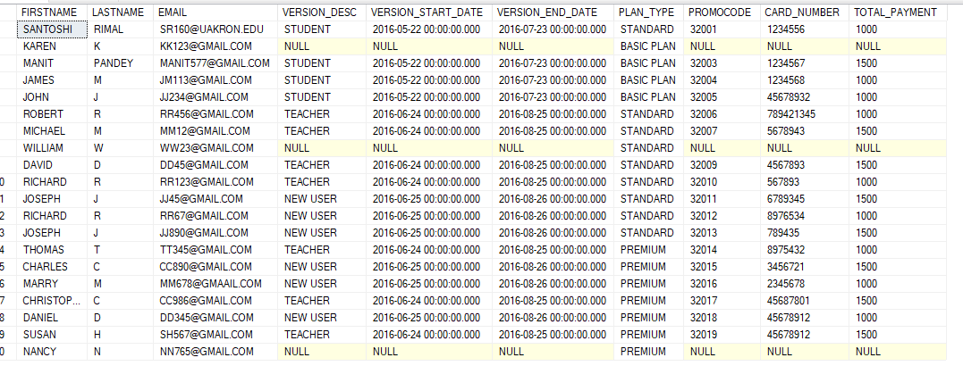

**REPORT2.**

CREATE VIEW V_REPORT2

AS

SELECT U.USERNAME,U.AGE, VT.VERSION_DESC AS VERSION_TYPE

,CQF.CATEGORY_DESC,CQF.SUB_CATEGORY_DESC, B.FLASHCARDNUM_FK, Q.QUIZLETNUM_PK,G.GAME_TYPE,G.START_TIME

,G.END_TIME

FROM T_USER U

INNER JOIN T_BRIDGE B ON U.USERID_PK = B.USERID_FK

INNER JOIN T_CATEGORY_QUIZLET_FLASHCARD CQF ON B.CATEGORYID_FK = CQF.CATEGORYID_PK AND B.SUB_CATEGORY_ID_FK = CQF.SUB_CATEGORY_ID_PK

INNER JOIN T_FLASHCARD F ON B.FLASHCARDNUM_FK = F.FLASHCARDNUM_PK AND CQF.CATEGORYID_PK = F.CATEGORYID_FK AND CQF.SUB_CATEGORY_ID_PK = F.SUB_CATEGORY_ID_FK

INNER JOIN T_QUIZLET Q ON B.QUIZLETNUM_FK = Q.QUIZLETNUM_PK AND CQF.CATEGORYID_PK = Q.CATEGORYID_FK AND CQF.SUB_CATEGORY_ID_PK = Q.SUB_CATEGORY_ID_FK

INNER JOIN T_GAME G ON B.GAME_ID_FK = G.GAME_ID_PK

LEFT JOIN T_USER_PAYMENT UP ON U.USERID_PK=UP.USERID_FK

LEFT JOIN T_VERSION_TYPE VT ON UP.VERSION_TYPE_ID_FK=VT.VERSION_TYPE_ID_PK

**Note:**

After creating this view user should be able to run the report to see what kinds of customer are using what kinds of products based upon different filters like version_Desc, Game_Type.

There was also a referential integrity issues between different combinations between different tables. Records had to be corrected in Bridge table to make it same Categoryid and Sub_Category_id to make it similar with T_caegory_quizlet_flashcard table and again the T_QUIZLET table has been edited to make the QUIZLETNUM, Categoryid and Sub_category_id similar in bridge table.

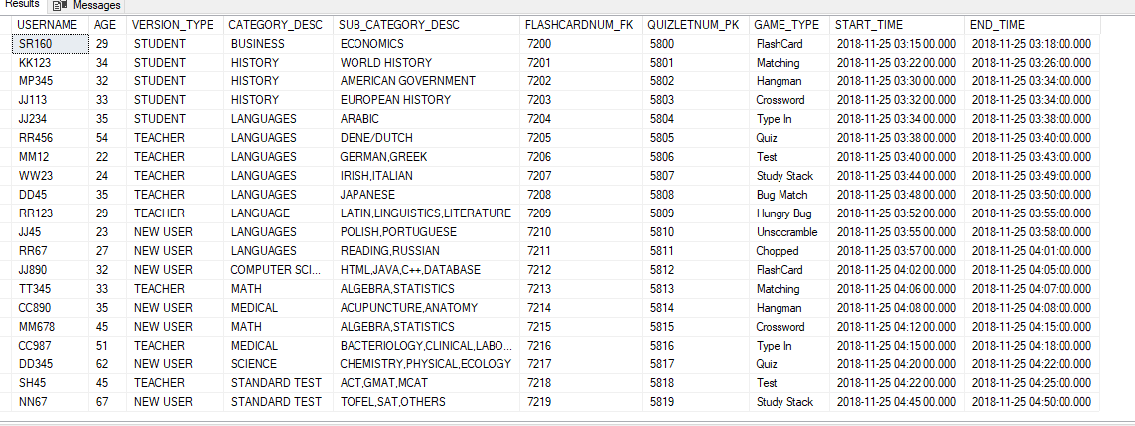

**Report 3.**

CREATE VIEW V_REPORT3

AS

SELECT PT.PRO_ID,U.USERID_PK,U.USERNAME,U.FIRSTNAME,U.LASTNAME,Q.QUIZLETNUM_PK

,W.TERM,G.GAME_TYPE,PT.START_TIME,PT.END_TIME,G.RESULTS,

CASE WHEN CAST(G.RESULTS AS INT) BETWEEN 70 AND 79 THEN 'C' WHEN CAST(G.RESULTS AS INT) BETWEEN 80 AND 89 THEN 'B' WHEN CAST(G.RESULTS AS INT) BETWEEN 90 AND 100 THEN 'A' ELSE 'FAIL' END AS SCORE

FROM T_PRO_TEACHER_TABLE PT

INNER JOIN T_USER U ON U.USERID_PK=PT.USERID_FK

INNER JOIN T_BRIDGE B ON U.USERID_PK=B.USERID_FK

LEFT JOIN T_QUIZLET Q ON PT.QUIZLETNUM_FK = Q.QUIZLETNUM_PK

LEFT JOIN T_GAME G ON B.GAME_ID_FK=G.GAME_ID_PK

LEFT JOIN T_WORD W ON G.WORD_ID_FK = W.WORD_ID_PK

**Note:**

After creating this report view the user (teacher) should be able to see how many quiz and scores their students achieved. The cast and case statement is used to convert the student result into score (i.e. A,B,C)

There was a mistake while defining the field PRO_ID in table T_PRO_TEACHER, it would have multiple userids (students) associated under one PRO_ID and no longer would be a primary key, the whole table had to be dropped and create a new table without primary key and all new data were inserted making sure no referential integrity would be violated

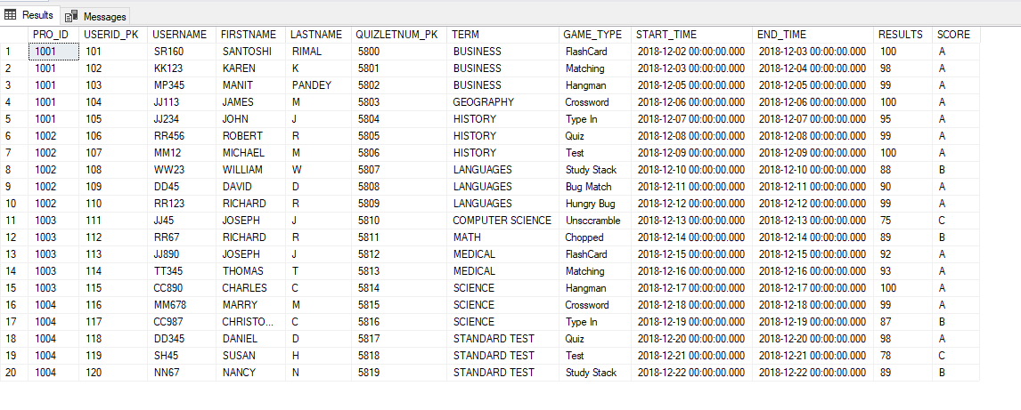

**Report 4.**

CREATE VIEW V_REPORT4

AS

SELECT A.ADVERTISEMENT_ID_PK,A.ADVERTISEMENT_STATE,A.STARTTIME,

A.ENDTIME,A.NUM_VIEWED,AP.VENDOR_NAME,AP.TOTAL_PAYMENT_AMOUNT

FROM T_ADVERTISEMENT A INNER JOIN

T_ADVERTISEMENT_PAYMENT AP ON A.ADVERTISEMENT_ID_PK =AP.ADVERTISEMENT_ID_FK

**Note:**

This was a simple report to focus on the advertisement, after creating the view report, user should be able to filter on different state.

There were no other issues detected while creating this report.

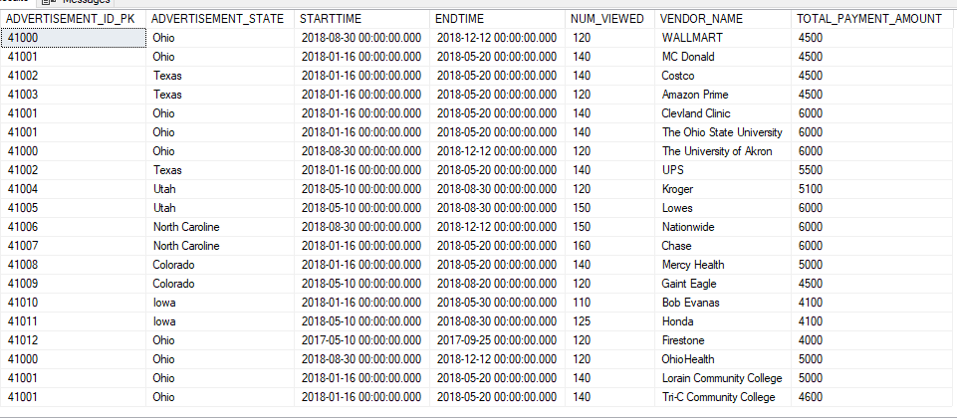

**Report 5.**

CREATE VIEW V_REPORT5

AS

SELECT C.CREATOR_ID_PK,F.FLASHCARDNUM_PK,W.WORD_ID_PK,G.GAME_ID_PK,G.START_TIME,G.END_TIME,U.USERID_PK

FROM T_CREATOR C

INNER JOIN T_BRIDGE B ON C.CREATOR_ID_PK = B.CREATOR_ID_FK

INNER JOIN T_USER U ON B.USERID_FK = U.USERID_PK

LEFT JOIN T_FLASHCARD F ON B.FLASHCARDNUM_FK = F.FLASHCARDNUM_PK

LEFT JOIN T_WORD W ON C.CREATOR_ID_PK = W.CREATOR_ID_FK

LEFT JOIN T_GAME G ON W.WORD_ID_PK = G.WORD_ID_FK

**Note:**

After creating this view the user should be able to filter report based upon their flashacards id and see how it is doing.

The FLASHCARDNUM_PK table was missing on the previous assignment in part of required tables and fields, and had to be added again everything was looking good.

Few of the word table related records are coming Null in the view but that was expected; some creator has just created the account and hasn’t done anything further.

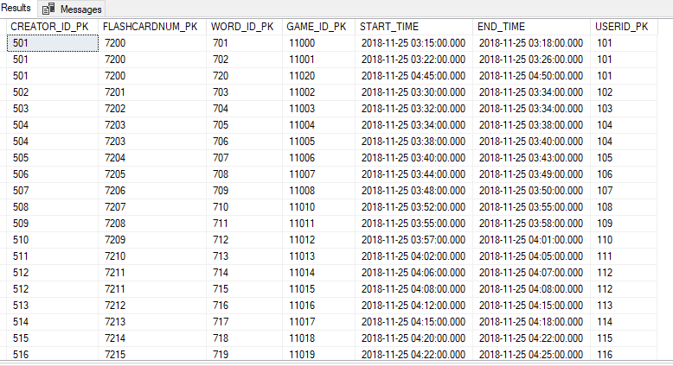

**Report 6.**

CREATE VIEW V_REPORT6

AS

SELECT G.GAME_ID_PK,B.USERID_FK,G.START_TIME,G.END_TIME

FROM T_GAME G

INNER JOIN T_BRIDGE B ON G.GAME_ID_PK = B.GAME_ID_FK

**Note:**

After creating this report the user can filter their game to see how it is doing. There was no issue found.

